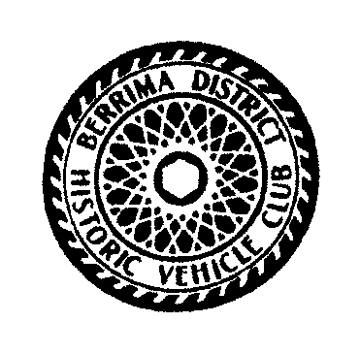
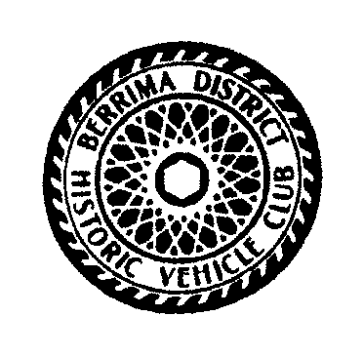
Berrima Rally 2020
Theme Heroes Heroines Villains & Vagabonds
Programme

Saturday 15th February 2020
Start 0800 Mittagong Markets . Cnr Alice & Albert St, Mittagong.
0830-0930 MITTAGONG PUBLIC SCHOOL enter via Lee Street, Mittagong.
You will be directed to park in your vehicles era.
Categories pre 1900 - 1919 1920 – 1929 1930 – 1939 1940 - 1949
1950 – 1959 1960 – 1969 1970 – 1979 1980 – 1990
Under 30 Driver Lady Driver
Motorcycles Commercial (Commercial includes trucks, utes and tractors)
Entrants & vehicles must attend both days to be eligible for category awards.
Register and join us for morning tea. Homemade slices, Saos, Tea, Coffee & Cordial.

1000-1200 Inspect vehicles on show and talk to the owners, take pictures, just enjoy yourself.
A judge will review all vehicles to select “ Best In Show” during this time
Check blackboard at hall for more suggested activities.

1200-1300 Lunch in hall Homemade Rissole/Sausage with Salad & Roll, your choice

1300-1330 Judges presentation “Best In Show” Saturday Awards

1400-1800 Drive and visit a new venue in Southern Highlands, directions are in your Rally Booklet
Or free time to wander Mittagong or Bowral or Moss Vale shops or check blackboard
1800- Themed Dinner - Hot smorgasbord carvery, beef /pork & hot vegetables. Desert Tea/Coffee

Sunday 16th February 2020
0830-0930 Start the morning at MITTAGONG PUBLIC SCHOOL.. Morning tea will be provided prior to run with Scones, Tea & Coffee.
Refer to your Rally Booklet with directions for your scenic drive
Return to MITTAGONG PUBLIC SCHOOL for lunch around 1200hrs.
1200-1300 Lunch – Cold smorgasbord, chicken/smoked ham with salads. Tea & Coffee
Presentation of weekend awards
Enquires Bill Betts 0429 333 769 robynbillbetts@gmail.com
Bill Flegg 0407 408 844 william.flegg@bigpond.com
Jenny Collins 0408 160 978 brujencollins@gmail.com

Rally........ Friendly, Relaxed, Casual and/or Fancy Dress
Theme Heroes Heroines Villains & Vagabonds

