“Bluebell” an 1911 Albion A3
Rod Holmes
About 1990, Peter Adams sister Susan, located an old Albion near Wauchope. It was completely dismantled, the parts were brought back to Newcastle and stored.
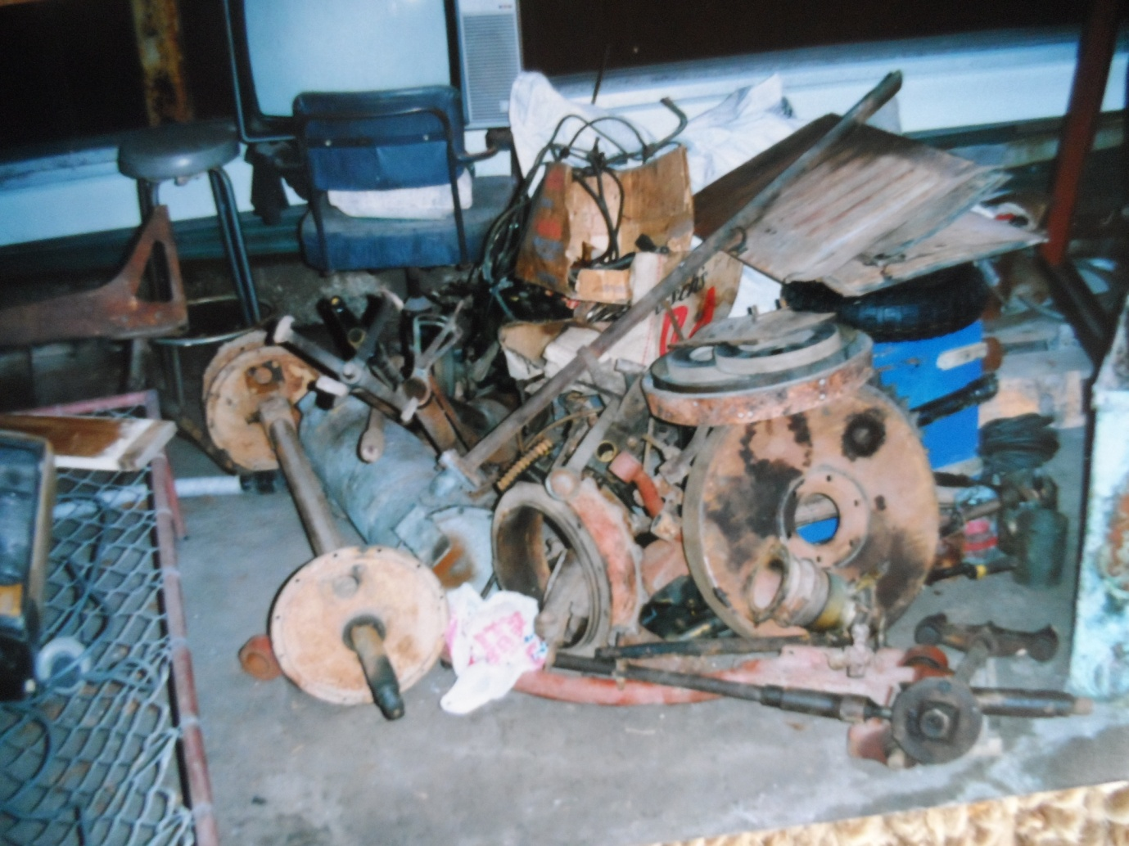

In 2000, the parts were acquired by Malcolm Bailey. Over the next 10 years he assembled the car making many parts in conjunction with Don Cuppledich from South Australia who was restoring a similar model A3 Albion.
I retired from farming in 2010 and decided to rekindle my interest in Veteran Cars. My two older brothers , Sandy had had “50 BOB’ a 1914 Vauxhall since 1950 and Keith with his 1908 Albion Lorry he has had since retrieving it from a neighbouring farm in 1948. Both were foundation members of the VCCA, Keith No 9 and Sandy No 10. They competed in the first Blue Mountains Rallies.

I had seen Malcolm Bailey’s Albion and purchased it in 2011. Malcolm had never had it running and had a temporary body fitted. We trailered it to Dorrigo where it sat beside Keith’s Albion. My wife, Ruth immediately christened it “Bluebell” because it was blue and came from Scotland.
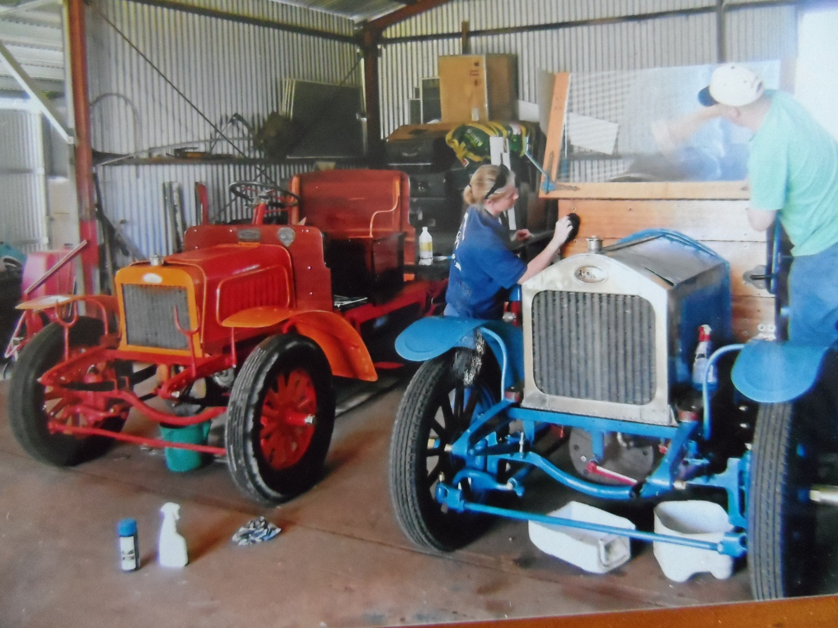
I flew to Perth to look at a similar car that was restored by John Riley at Newcastle in 1970. It is now owned by Bruce Carmicheal and is an great example of an excellent restoration and ongoing maintenance. I realised my car had the potential for restoration, so I took many photos for reference.
The engine was removed and with the help of many friends, reset the timing gears, valves and piston rings. The rest of the engine seemed OK.
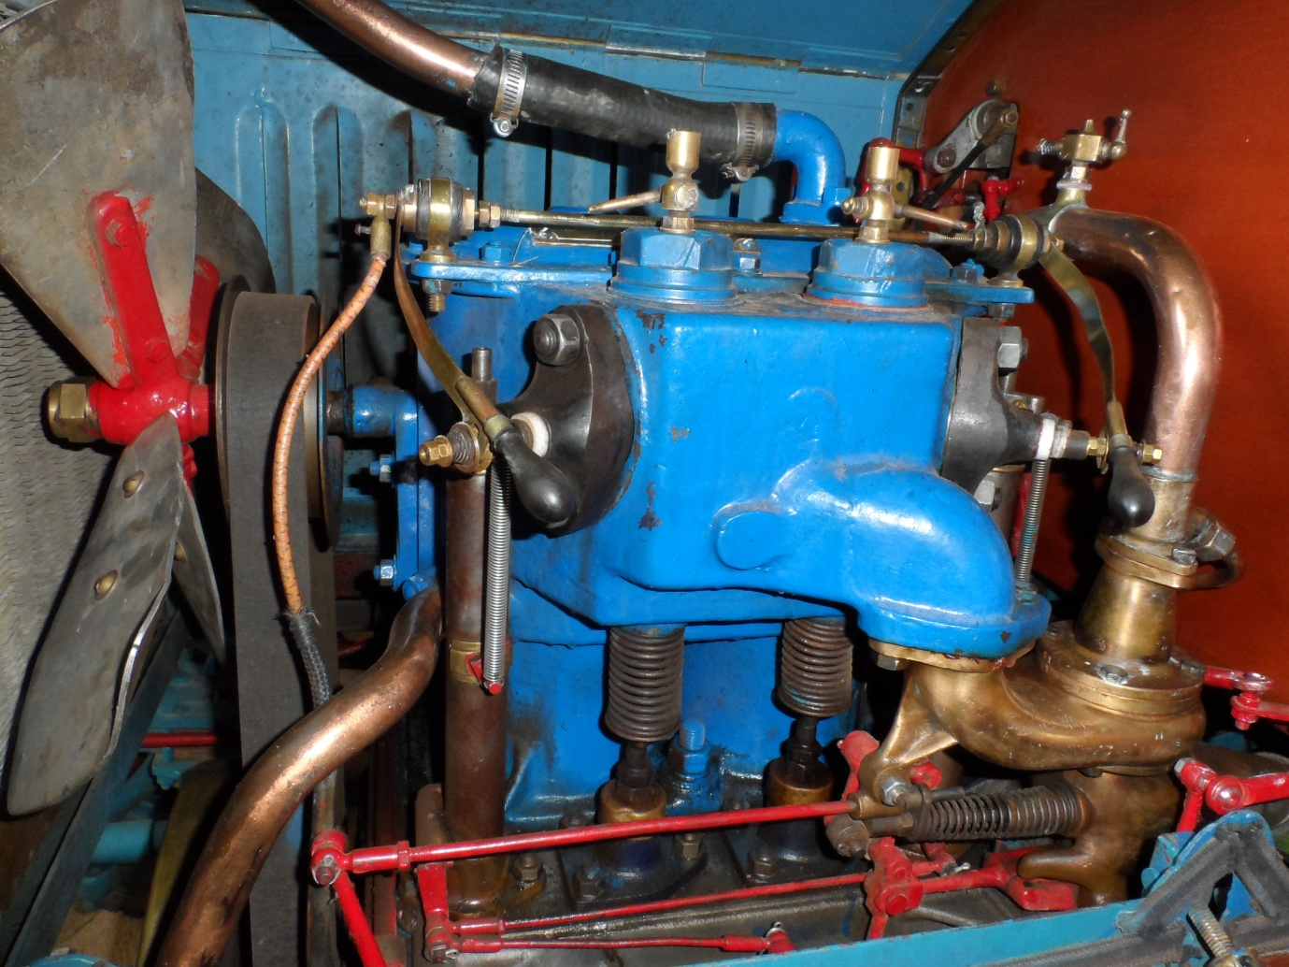

After many adjustments to the timing, using a copy of the original handbook. We had the engine running but had ongoing problems with the ignition. The 2 cylinder engine has low tension ignition from bar magnets spinning past fixed coils in front of the engine with a live rod on the top of the block that goes to Igniters inside the combustion chamber. The spark is created by a make and break points activated from the camshaft.
The ongoing problem has been the insulation of the live terminal through the head and the points. Initially I tried silver solder for points but they pitted quickly. Keith’s lorry still had its original platinum points so I got our local jeweller to make up new platinum points which work perfectly. I have not been so fortunate with the insulation. Trying out high temperature synthetics which all melted, then using mica as used on the lorry. I have been unable to pack the mica tightly enough and they build up carbon between the sheets and short out. Finally a friend cast porcelain inserts that seem to be lasting.

I might add that Keith’s Lorry runs perfectly with its original igniters after 109 years.
After getting the engine running we realised the chains for the final drive were the wrong size. The pitch was right but they were one inch wide while the sprockets were 5/8 inch, the chain was hitting the case. As chain was not available in that size, we dismantled the chain and cut every pin and roller back and then machined them to size before reassembling each chain, a mammoth job.
I refitted the temporary body and used Bluebell for my daughters wedding, a proud day for me and the car. Then it was stripped to the chassis, brakes ,
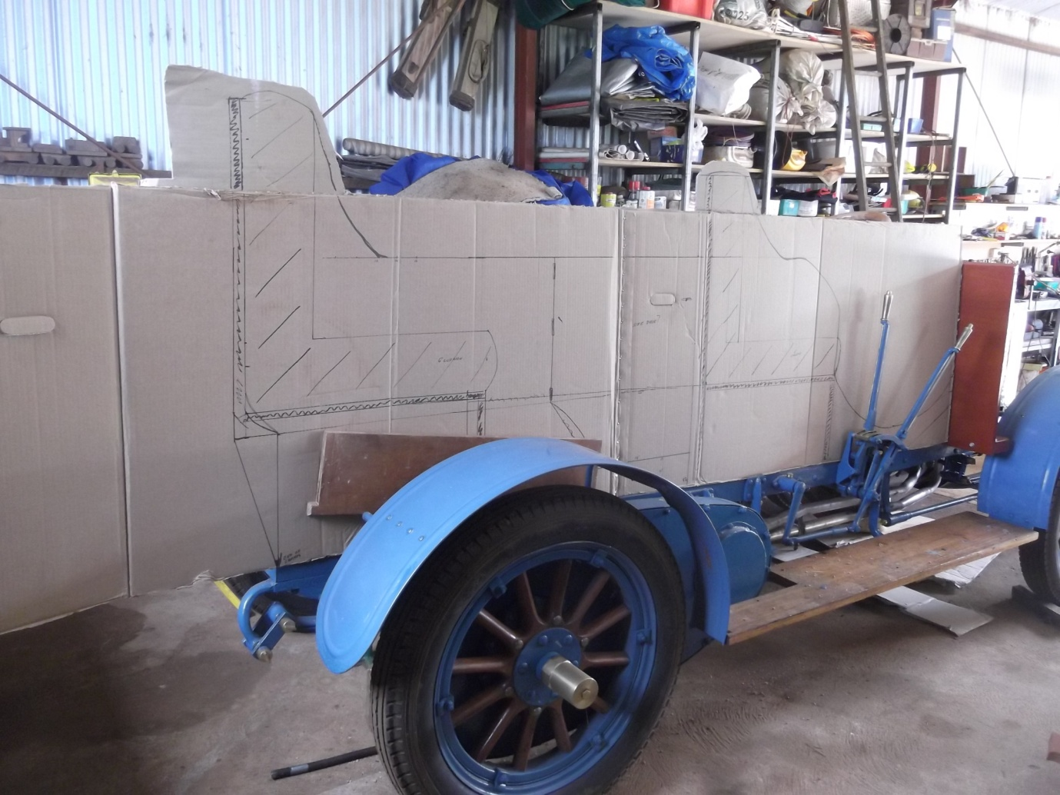
grease cups, and running gear all checked. Then the chassis hand painted. To get the body proportions correct, I made up cardboard profiles typical of 1911 vehicles. With the assistance of a neighbouring woodworker built the entire
body ,using Dorrigo Rosewood, cut off our farm. This is a strong, durable timber with attractive figuring and colour.
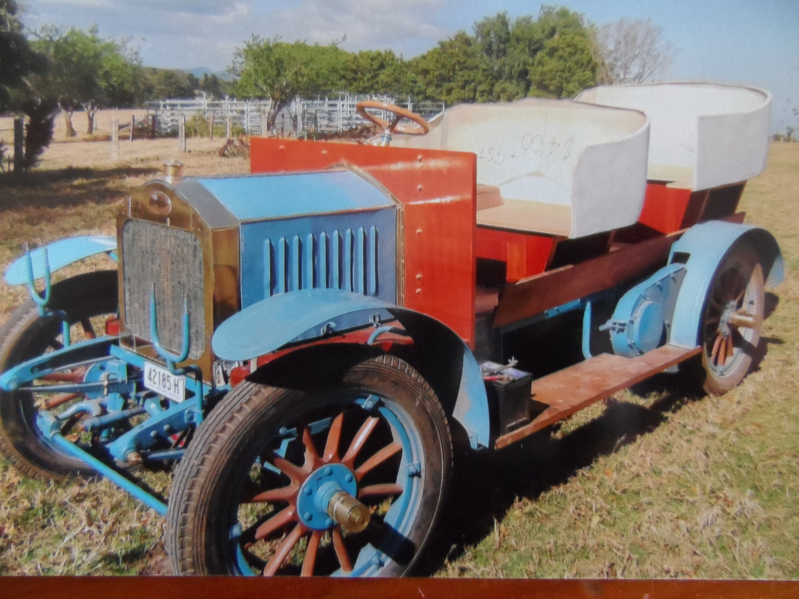

For the seat buckets I used an old seat to make a plaster cast, then cut it in half and added an extra 6inches in width, before using the casting to make fibreglass skins. Then fitting internal timber to strengthen them, before sending the seats, mudguards, bonnet, and fuel tank to be spray painted using a 2 pack paint.
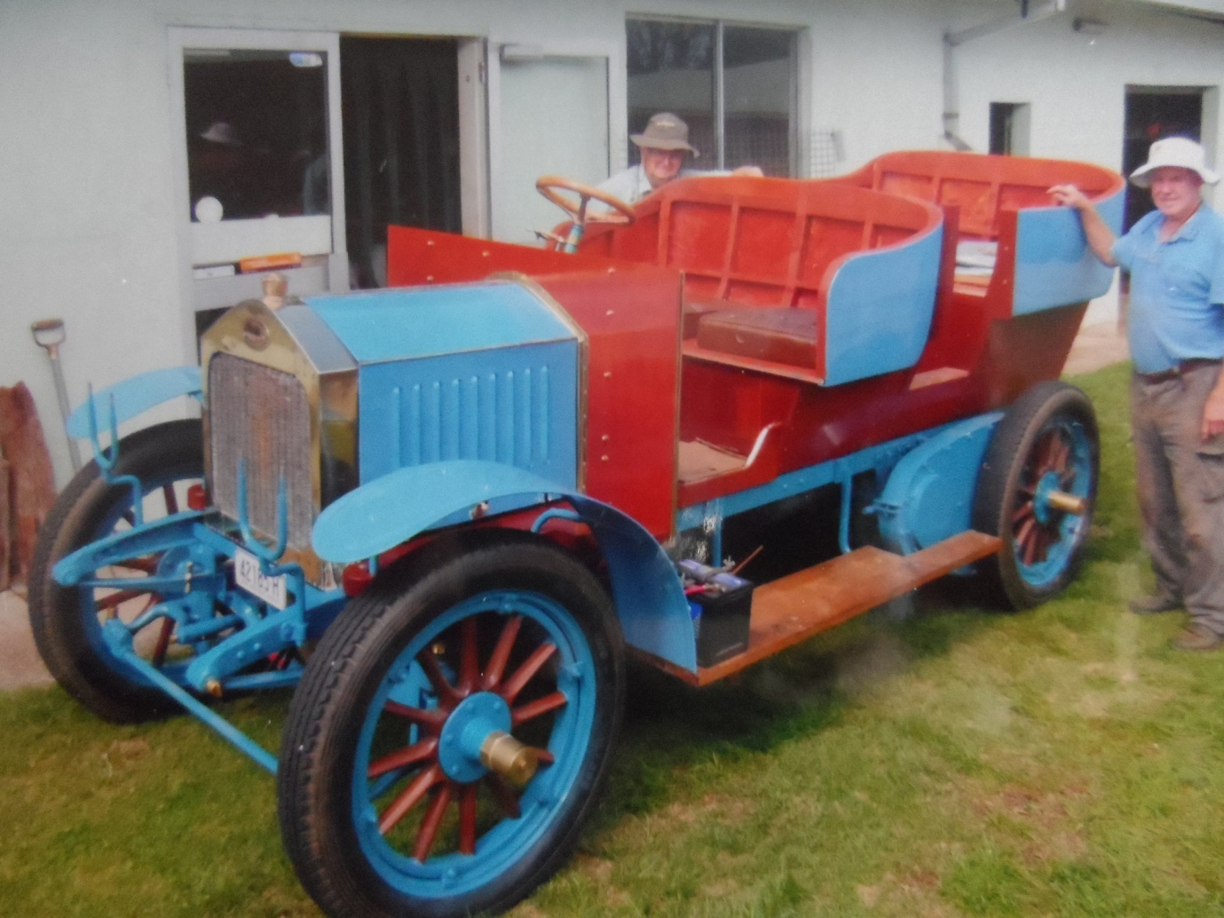

I took the car to Bargo for upholstery and a hood, using leather and materials sourced from the Amish in USA. The leather was half the price of local hides
.I am happy with the result, however I should have made the windscreen first, to lower the hood about 4 inches.
The first rally was the 1-2 cylinder in Canberra. All went well until the 3rd. day when the water pump cracked, temporary repairs continued to open up more cracks. A new pump had to be cast and machined. The next job was to fit a windscreen, the frame was cast in gunmetal using the Clubs “Auster” patterns which were machined and polished, then the frame and glass made to size.

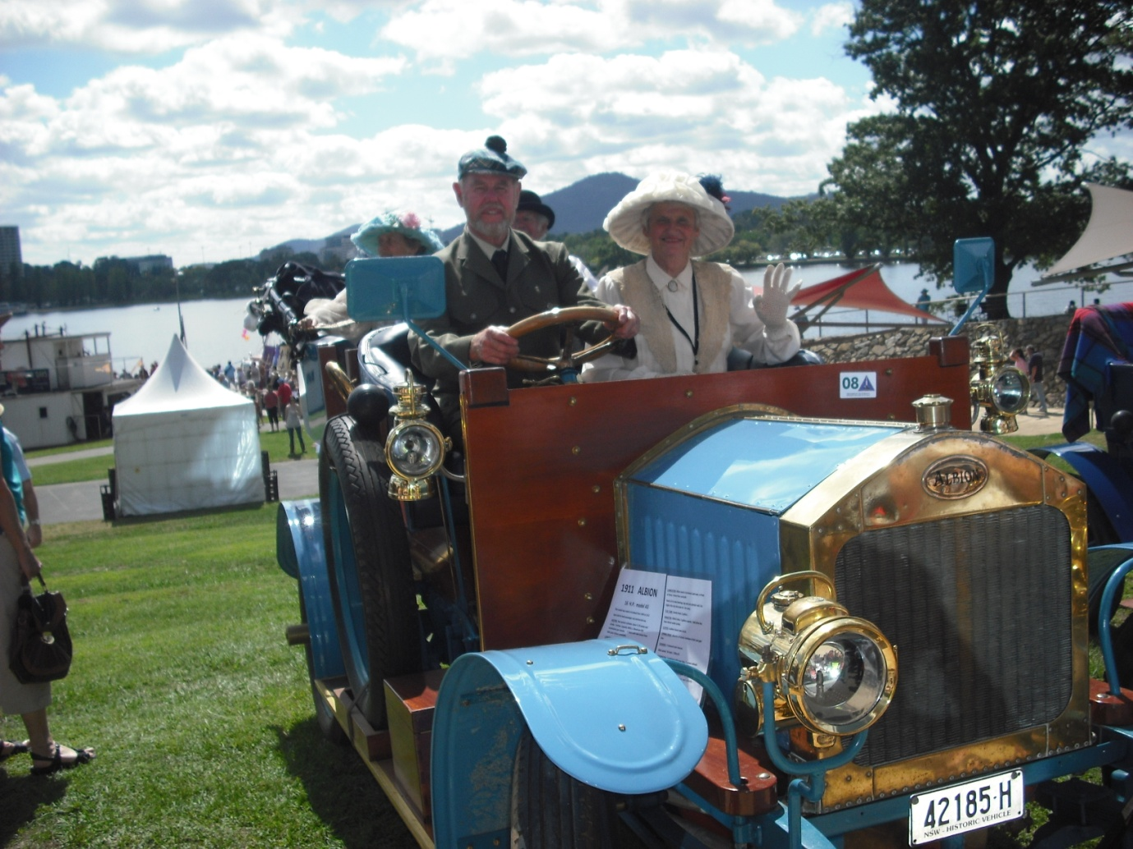
In 2015 we took Bluebell on the trailer to Kalgoorlie WA. For the National Rally and to run it with Bruce Carmicheals A3.Bluebell was much noisier in the transmission, otherwise performance was similar.
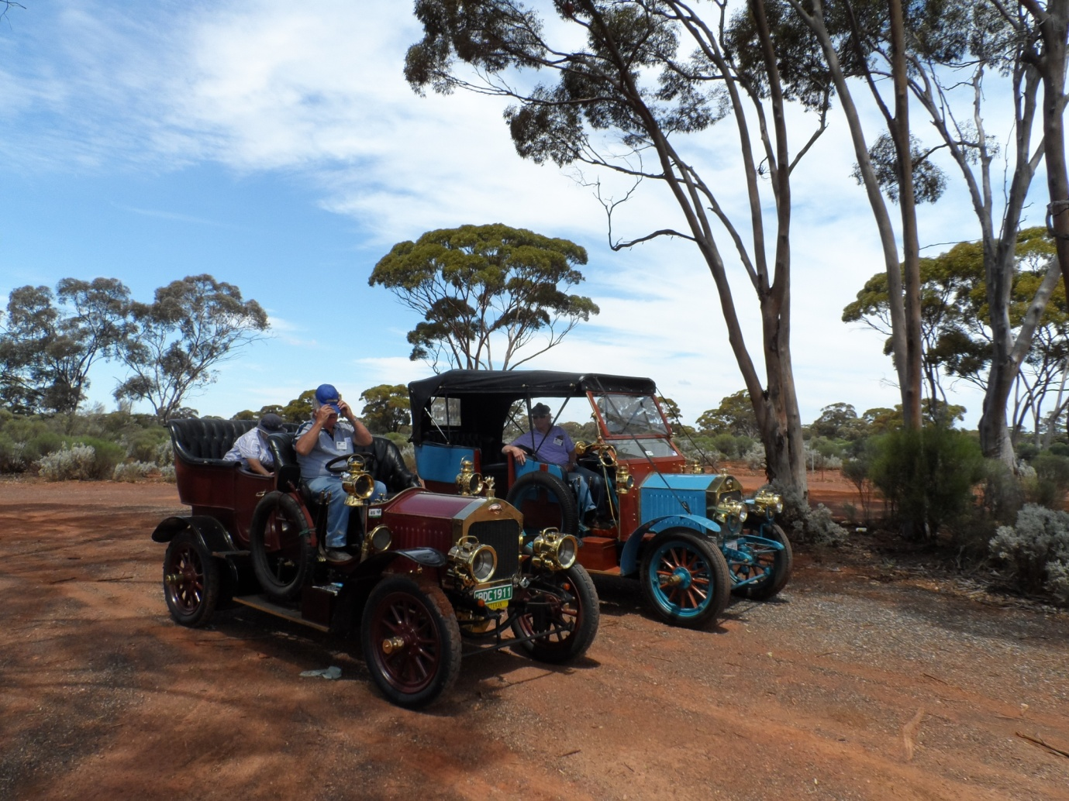
When we got home I removed the body to access the gearbox/diff housing which is a large single unit. The main problem seemed to be the clearance between the two crown wheels which are different diameters and the pinions. The thrust races are the only ball races in the whole vehicle, I replaced them with thicker ones to make the gears mesh closer. This greatly reduced the gear noise. I also realigned the sprockets on the chain drive to the rear wheels.
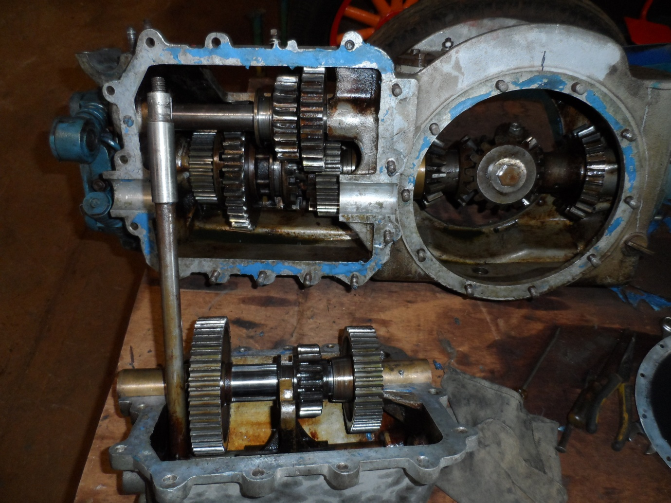
With the body back on we have been to the 2015 Goulburn National rally and Qld. Rallies at Dalby and Yamba.
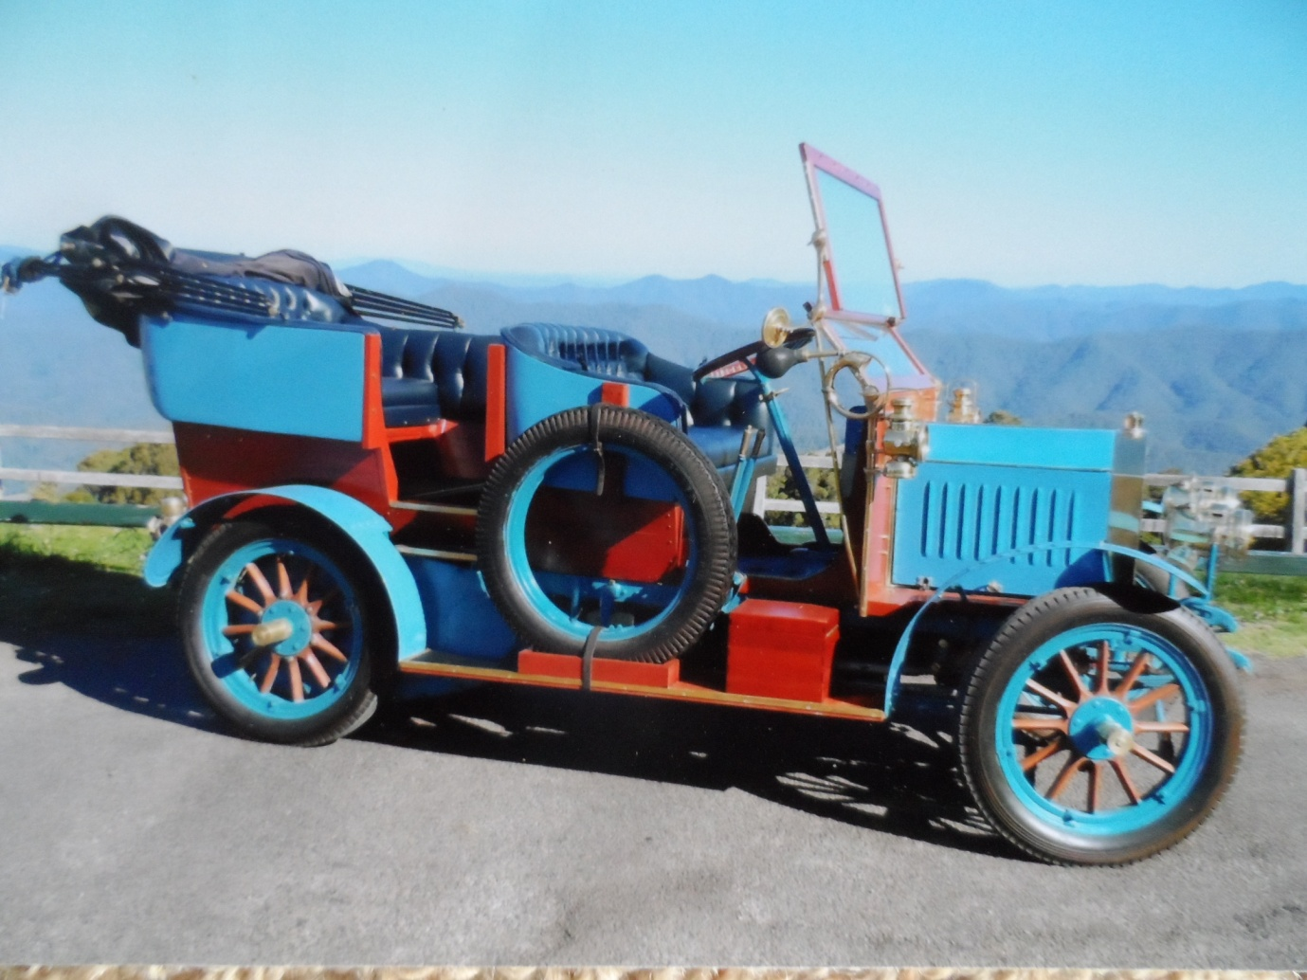
Bluebell is not a vehicle for long runs as top speed is only 30 Kph. However I have had a lot of pleasure out of the restoration and driving of my veteran.
I owe a tremendous thanks to the many friends who have assisted in the restoration.
VEHICLE DETAILS
Make - ALBION-built in Glascow, Scotland.
Model – A3. 16h.p. Manufactured from 1904 till 1912 with little change.
Sold in chassis form for both passenger and commercial use.
Engine- 2 cylinder, bore 4.5 inches stroke 5 inches, capacity 3 litres, 16 H.p.
Low tension ignition, mechanical make & break ignition. Max 980 revs/minute.
Speed, mixture and timing controlled by a governor.
3 speed gearbox, maximum speed 20MPH. Chain drive to rear wheels.

