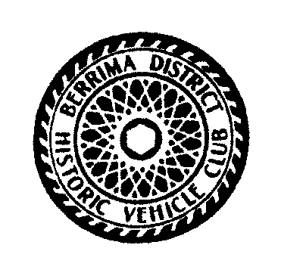
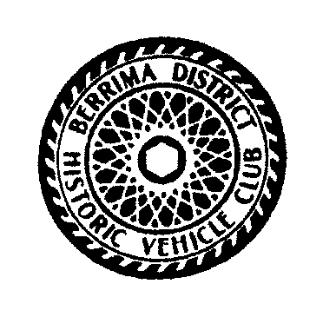
Berrima District Historic Vehicle Club Inc
Invitation
to our
44th BERRIMA RALLY
Saturday 15th to Sunday 16th February 2020

Once again the Berrima District Historic Vehicle Club Inc will be holding our “Berrima Rally”
on the weekend mentioned above.
Our theme for this weekend will be “Heroes Heroines Villains & Vagabonds”
We are looking forward to your participation with this theme.
Our club welcomes all historic vehicle enthusiasts to our major annual rally, a weekend in the Southern Highlands with country hospitality and motoring through some exciting country.

Come for the weekend or just for the day (to be eligible for category trophies, entrants & vehicles must attend both days)
All required information is in the attached programme

We are all looking forward to meeting again old friends and many new ones.

We have enclosed an entry form and a programme of the weekend’s events.
If more entry forms are required feel free to copy as many as you need.

We have, for your convenience, listed below various places for accommodation in the area.
Booking early is recommended

Mittagong RSL Springs Resort Ph 02 4871 3133 mittagong@springsresorts.com
Grand Country Lodge Ph 02 4871 3277 grandcountrylodgemittagong@gmail.com
Fitzroy Inn Historic Guest House Ph 02 4872 3457 bookings@fitzroyinn.com.au
Mittagong Caravan Park Ph 02 4871 1574 info@mittagongcaravanpark.com.au
Mittagong Motel Ph 02 4871 1277 enquiries@mittagong-motel.com.au
Motel Melrose Ph 02 4871 1511 bookings@motelmelrose.com.au
Poplars Inn Mittagong Ph 02 4889 4239 info@poplarsinn.com.au
Destination Southern Highlands – free booking service 1300 657 559 or 02 4871 2888
NRMA Accommodation Guide www.mynrma.com.au/travel

Please register early as it will assist us in planning.
Closing Date for Registering 31st January 2020
SEE YOU ALL IN FEBRUARY 2020
The Rally Committee

ALL STARTS AND MEALS FROM MITTAGONG PUBLIC SCHOOL . ENTRY ....LEE STREET MITTAGONG.

