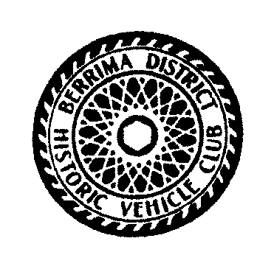
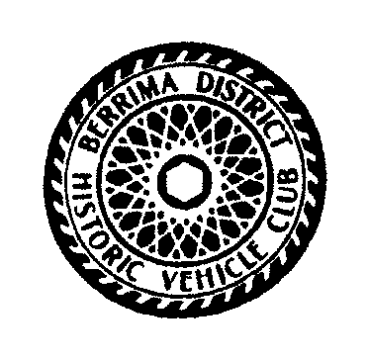
Berrima District Historic Vehicle Club Inc
Berrima Rally 2020
Entry Form
Saturday 15th & Sunday 16th February 2020
Rally Entries Close 31st January 2020

Entrants Name_______________________________________________
Passengers Names____________________________________________
Address____________________________________________________
Suburb_______________________________________ Postcode________
Ph ____________ Mobile___________________ Email_______________________

Vehicle Details
Make _______________ Model __________________ Style __________________
Year__________ Rego No _____________ Under 30 ______ Female Driver____
Primary Club ___________________________________________________

Please return the entry form plus cheque made out to
BDHVC Rally
PO Box 145 Mittagong, NSW, 2575
Or Bank Transfer to
Account Name – BDHVC – BSB 062572 – A/C 00902244
Reference Your Surname & Initial
If paying by bank transfer please forward entry form to above PO Box
or email form to brujencollins@gmail.com
Please circle attending Weekend or Saturday or Sunday
Day Event Charge ADULTS /Children Costs
Sat 16th Entry Fee Per Car Includes $ 40.00
Sun 17th Morning Tea Saturday & Sunday
Rally Badge $20.00ea $
Sat 16th Lunch A $10.00 .......Adult $
C $5.00 .......Child $
Sat 16th Dinner A $25.00 ........Adult $
C $12.50 ........Child $
Sun 17th Lunch A $15.00 .........Adult $
C $7.00 .........Child $

Special Diets available Request on this form TOTAL $

